Day 23
Task 1: Tags
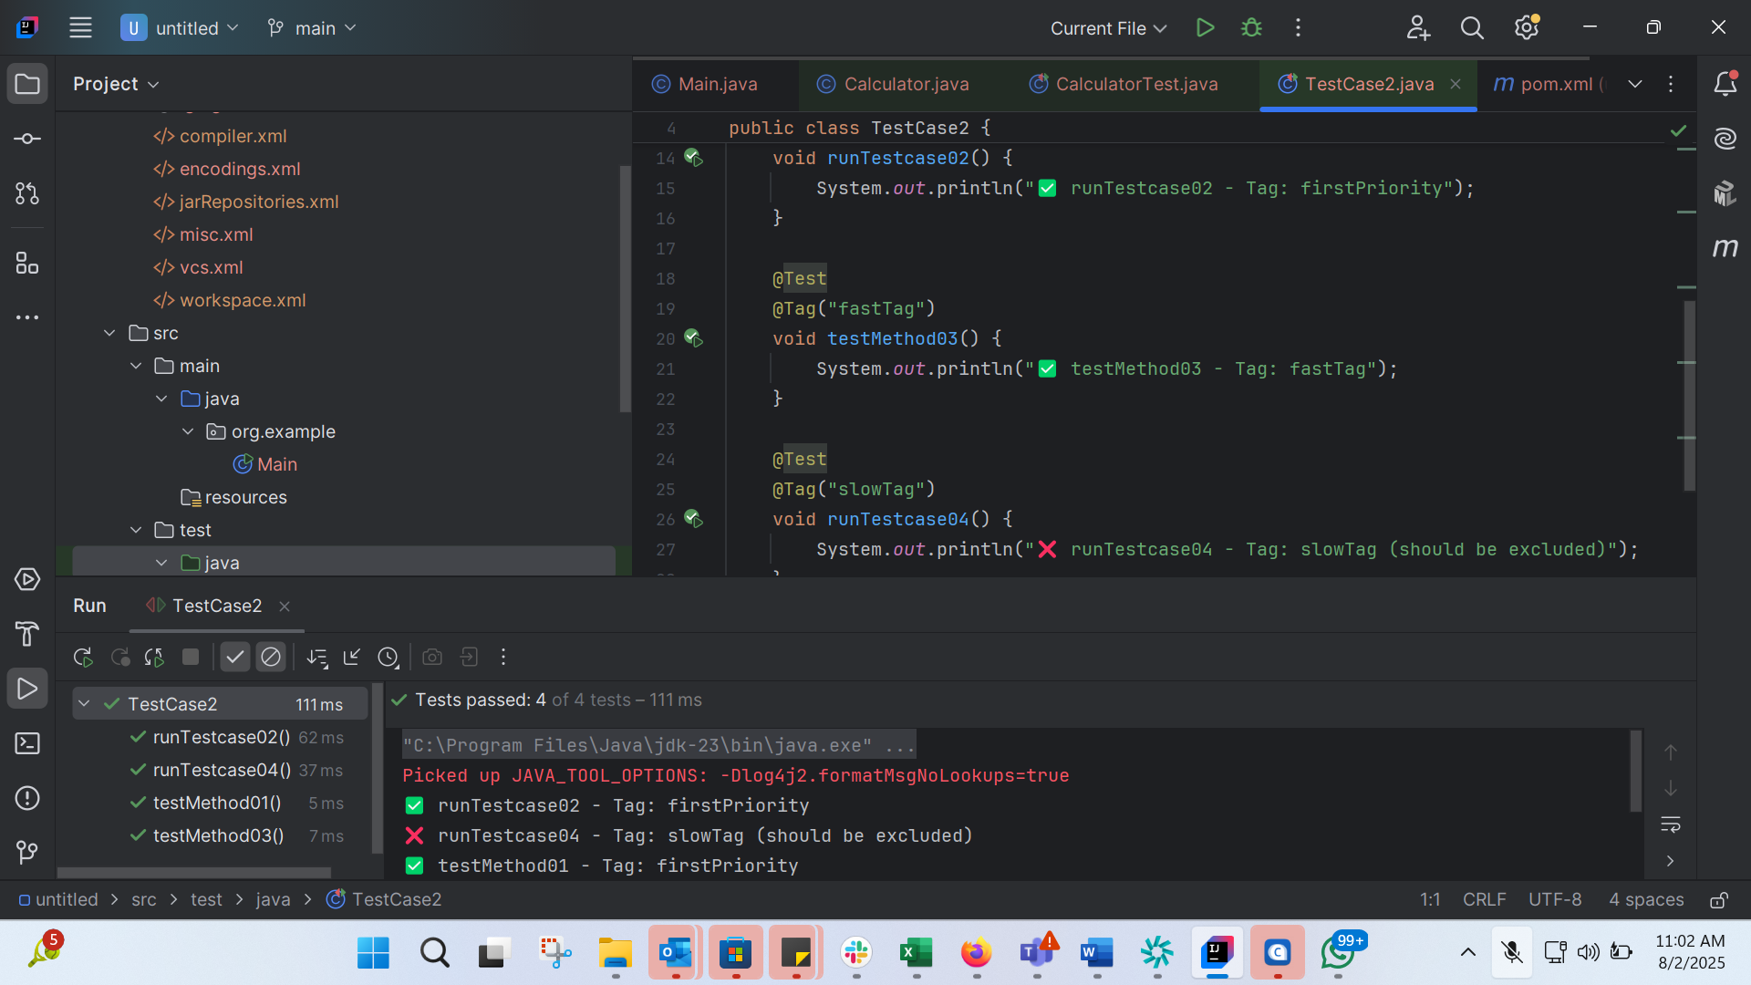
import org.junit.jupiter.api.Test;
import org.junit.jupiter.api.Tag;
public class TestCase2 {
@Test
@Tag("firstPriority")
void testMethod01() {
System.out.println("✅ testMethod01 - Tag: firstPriority");
}
@Test
@Tag("firstPriority")
void runTestcase02() {
System.out.println("✅ runTestcase02 - Tag: firstPriority");
}
@Test
@Tag("fastTag")
void testMethod03() {
System.out.println("✅ testMethod03 - Tag: fastTag");
}
@Test
@Tag("slowTag")
void runTestcase04() {
System.out.println("❌ runTestcase04 - Tag: slowTag (should be excluded)");
}
}

Task 2:
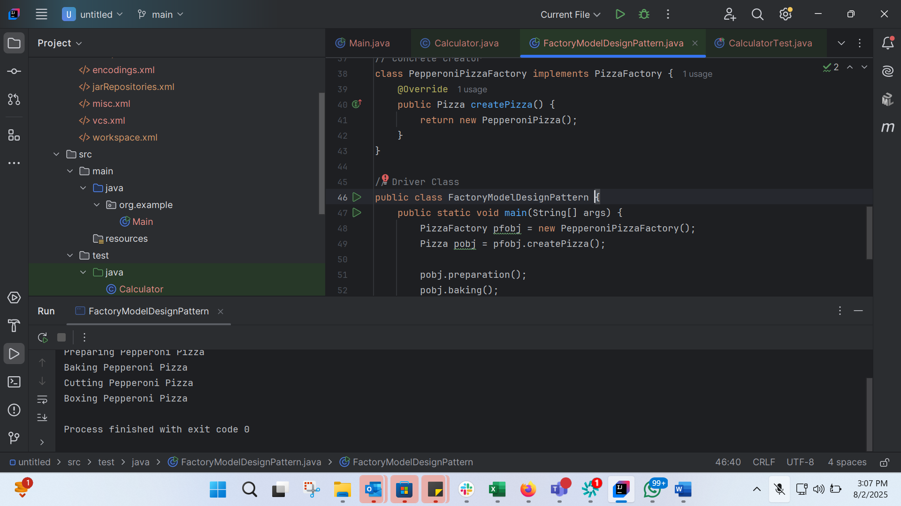
// Product Interface
interface Pizza {
void preparation();
void baking();
void cutting();
void boxing();
}
// Concrete Product
class PepperoniPizza implements Pizza {
@Override
public void preparation() {
System.out.println("Preparing Pepperoni Pizza");
}
@Override
public void baking() {
System.out.println("Baking Pepperoni Pizza");
}
@Override
public void cutting() {
System.out.println("Cutting Pepperoni Pizza");
}
@Override
public void boxing() {
System.out.println("Boxing Pepperoni Pizza");
}
}
// Creator Interface
interface PizzaFactory {
Pizza createPizza();
}
// Concrete Creator
class PepperoniPizzaFactory implements PizzaFactory {
@Override
public Pizza createPizza() {
return new PepperoniPizza();
}
}
// Driver Class
public class FactoryModelDesignPattern {
public static void main(String[] args) {
PizzaFactory pfobj = new PepperoniPizzaFactory();
Pizza pobj = pfobj.createPizza();
pobj.preparation();
pobj.baking();
pobj.cutting();
pobj.boxing();
}
}

Task 3: SingletonDemo
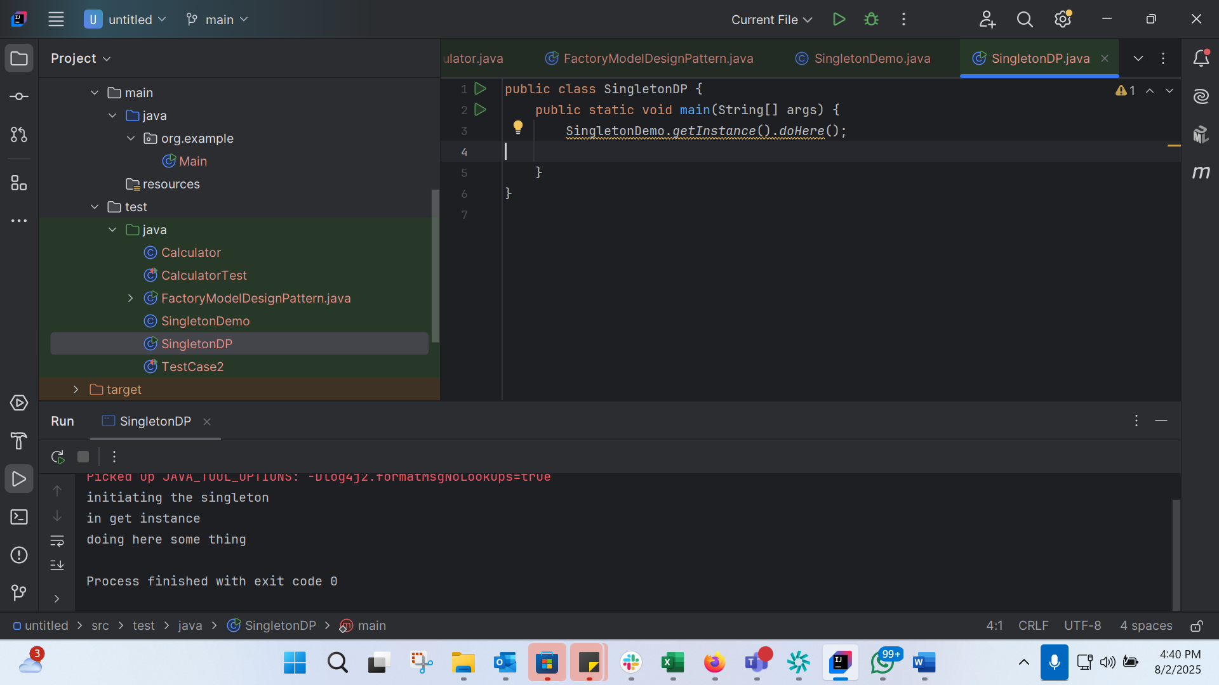
class SingletonDemo {
private static SingletonDemo instance; // lodinids.. //pass/ pin no
private SingletonDemo() {
System.out.println("initiating the singleton");
}
public static SingletonDemo getInstance() {
if (instance == null) {
instance = new SingletonDemo();
System.out.println("in get instance");
}
return instance;
}
public static void doHere() {
System.out.println("doing here some thing");
}
}

public class SingletonDP {
public static void main(String[] args) {
SingletonDemo.getInstance().doHere();
}
}

Task 4:

